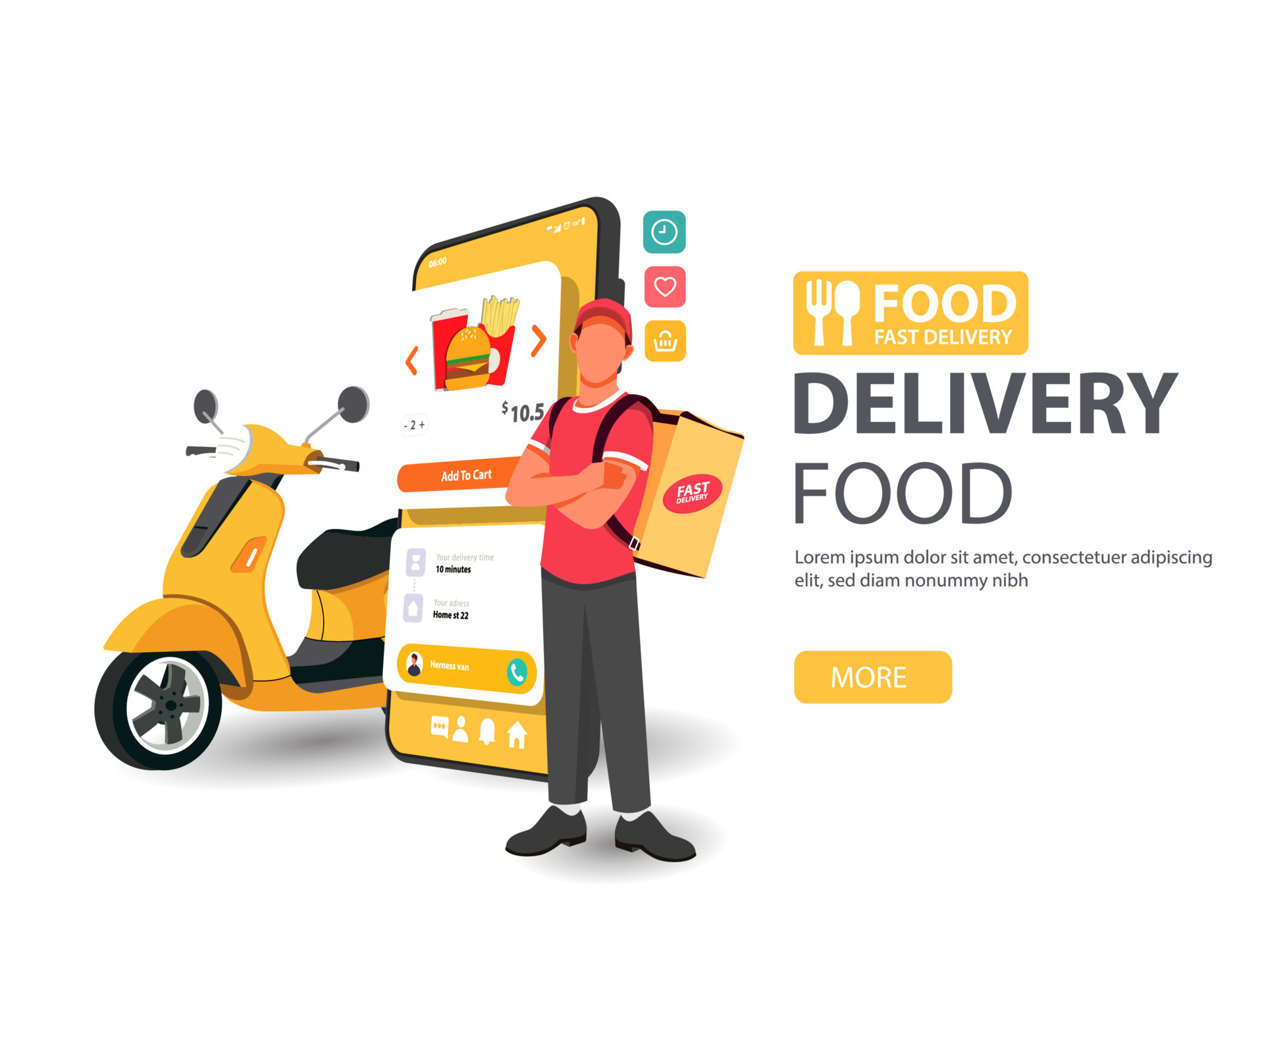
Contents:
Introduction
SystemExisting
Proposed System
Software Requirements
Hardware Requirements
Architectural diagram
Data flow diagram
Table Design
Data Dictionary
Relational diagram
Program design
Testing
Conclusion
References
Source code
Screen shot

Introduction:

The food delivery industry is a rapidly growing market, and customer satisfaction is becoming increasingly important. One of the key factors that affects customer satisfaction is the delivery time. An accurate delivery time prediction model can help food delivery businesses to improve customer satisfaction, optimise operations, and streamline logistics.
This project will develop a food delivery time prediction model using machine learning. The model will be trained on a dataset of historical delivery data. The data will include information such as the restaurant location, the customer location, the order time, and the delivery time. The model will be able to pred
Existing System :

The existing system for food delivery time prediction is typically based on a set of heuristics. These heuristics are based on the experience of the food delivery company and may include factors such as the distance between the restaurant and the customer, the time of day, and the day of the week.
The existing system has a number of limitations. First, it is not based on any data, so it cannot be used to predict delivery times for new orders. Second, heuristics are often based on the experience of a single person or team, so they may not be accurate for all orders.
Proposed System :
The proposed system for food delivery time prediction is based on machine learning. The machine learning model will be trained on a dataset of historical delivery data. The data will include information such as the restaurant location, the customer location, the order time, and the delivery time.
The proposed system has a number of advantages over the existing system. First, it is based on data, so it can be used to predict delivery times for new orders. Second, the machine learning model can be trained on a large dataset, so it is more likely to be accurate than the heuristics-based system.
The following table summarises the differences between the existing system and the proposed system:
Feature Existing system Proposed System
Data Based on heuristics Based on historical delivery data
Accuracy May not be accurate More likely to be accurate
Scalability Not scalable Scalable to large datasets

Software Requirements:

=>8GB Ram
=>256 internal memory
=>intel processor

Hardware Requirements:

=>window os
=>Python Gui or Anaconda navigator(Anaconda jupyter)

Architectural diagram:

The following architectural diagram shows the high-level architecture of the food delivery time prediction project:

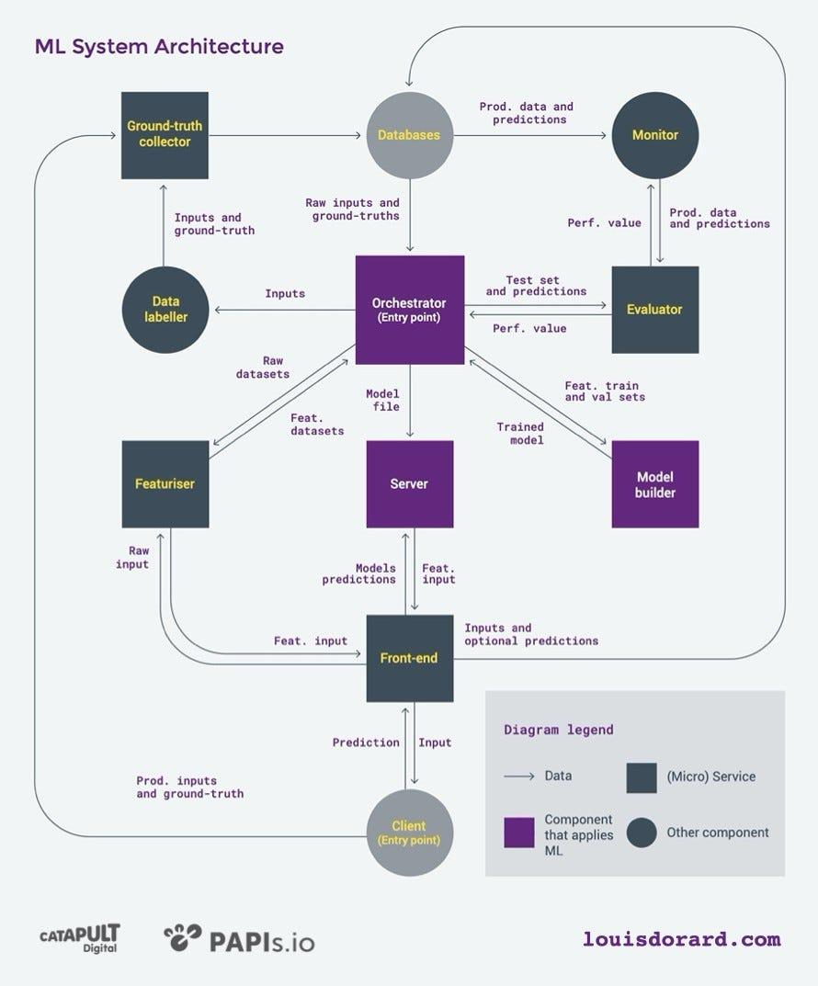
The project consists of the following components:
- Data collection: The data collection component is responsible for collecting the historical delivery data. The data will be collected from the food delivery company's database.

- Data cleaning: The data cleaning component is responsible for cleaning the historical delivery data. The data will be cleaned to remove any errors or inconsistencies.

- Feature engineering: The feature engineering component is responsible for creating features from the historical delivery data. The features will be used to train the machine learning model.

- Machine learning model: The machine learning model is responsible for predicting the delivery time for new orders. The model will be trained on the historical delivery data.

- Delivery time prediction: The delivery time prediction component is responsible for predicting the delivery time for new orders. The prediction will be made based on the output of the machine learning model.
Data flow Diagram:

The following data flow diagram shows the flow of data through the food delivery time prediction project:

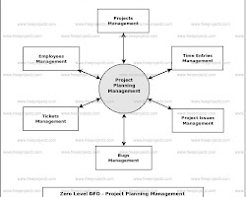

The data flow diagram shows that the data collection component collects the historical delivery data from the food delivery company's database. The data cleaning component cleans the historical delivery data. The feature engineering component creates features from the historical delivery data. The machine learning model is trained on the historical delivery data. The delivery time prediction component predicts the delivery time for new orders based on the output of the machine learning model.

Table Design:

Table Name | Description
food_delivery_time_prediction | This table stores the data that is used to predict the delivery time for food orders.

Data Dictionary:

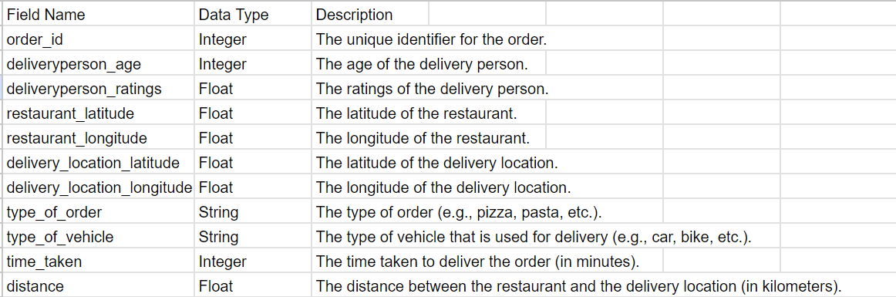

Relational Diagram :

The following relational diagram shows the relationships between the tables for the food delivery time prediction project:
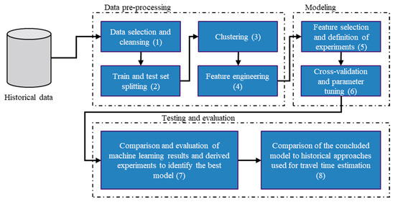

The relational diagram shows that the orders table is related to the delivery_times table, the features table, and the model table. The delivery_times table is related to the features table. The model table is related to the features table.
Program Design:
The program design for the food delivery time prediction project is as follows:
- The program will be written in Python.
- The program will use the Scikit-learn library for machine learning.
- The program will be modularized into the following components:
  - Data collection
  - Data cleaning
  - Feature engineering
  - Machine learning model training
  - Delivery time prediction
- The program will be tested
Testing :
- Unit testing: Unit testing is used to test individual units of code. This can be used to test the data collection, data cleaning, feature engineering, and machine learning model training components of the project.
- Integration testing: Integration testing is used to test how different units of code interact with each other. This can be used to test the delivery time prediction component of the project.
- System testing: System testing is used to test the entire system. This can be used to test the food delivery time prediction project as a whole.
In addition to these testing techniques, the project can also be evaluated using the following metrics:
- Accuracy: The accuracy of the model is the percentage of times that the model makes a correct prediction.
- Precision: The precision of the model is the percentage of times that the model predicts a positive outcome when the actual outcome is positive.
- Recall: The recall of the model is the percentage of times that the model predicts a positive outcome when the actual outcome is positive.
The conclusion of the project will depend on the results of the testing and evaluation. If the model is accurate, precise, and has good recall, then the project can be considered a success. However, if the model is not accurate, precise, or has poor recall, then the project will need to be revised.
Conclusion:

The data dictionary shows that the following factors can be used to predict the delivery time for food orders:
- The age of the delivery person
- The ratings of the delivery person
- The latitude and longitude of the restaurant
- The latitude and longitude of the delivery location
- The type of order
- The type of vehicle
- The distance between the restaurant and the delivery location
These factors can be used to train a machine learning model that can predict the delivery time for new orders. The model can be used to improve customer satisfaction and optimise operations for food delivery companies.

In addition to the factors listed above, there are other factors that could be considered for predicting delivery time, such as the time of day, the day of the week, and the weather condition. These factors could be included in the model to improve the accuracy of the predictions.
The development of a food delivery time prediction model is a complex task, but it can be a valuable tool for food delivery companies. The model can be used to improve customer satisfaction, optimise operations, and make better decisions about the allocation of resources.

Reference:

=>By using above data we can predict the time taken to delivery the food .we can used the machine learning algorithms to predict the food delivery time

=>we are taking data from database in these data we haveDeliveryperson_Age, Deliveryperson_Ratings,Restaurant Latitude,Restaurant_longitude, Deliverylocation_latitude,Delivery_location_longitude,Type_of_order ,Type_of_vehicle,Time_taken(min),Distance by using we can find the delivery time

=>we are implementing the multiple machine learning algorithms like svr,knn,decision tree regressor,random forest regressor,xgboost,and more to reach our condition to predict the time

=>we will evaluate the project to measure the accuracy and precision and recall for the predicted data and find the how accurate the model

=>Once we trained the model after the evaluated we can predict the time for delivery the food
After these we can deploy the model into server
